OHIS User Adapter
Kit Packing Sheet
In a 6” x 4” 4mil poly bag, place the following:
Part | Qty | Picture
Circuit board | 1 | 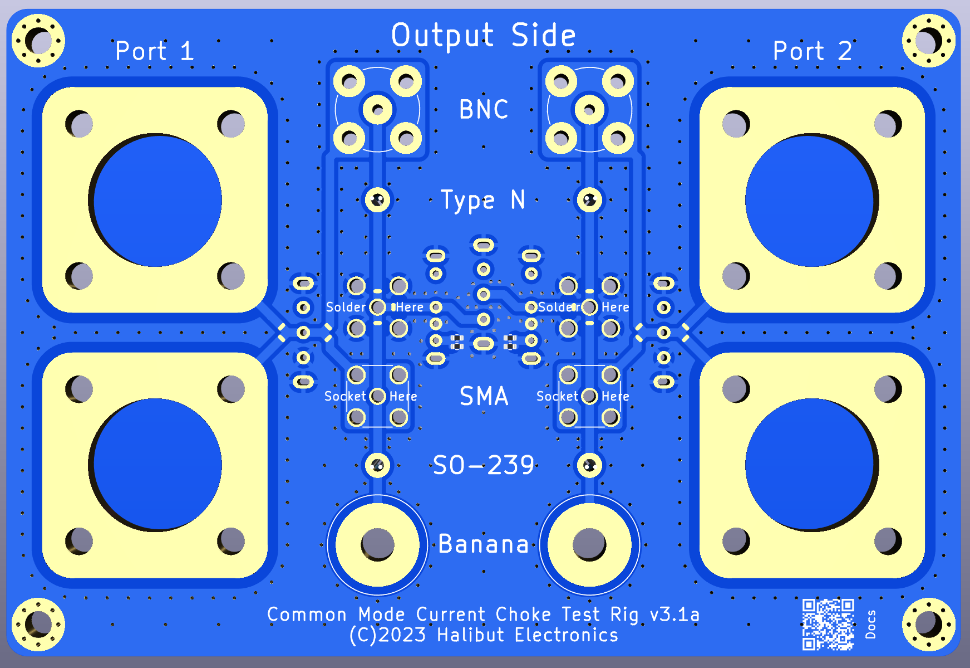
Business card, on Output Side of board, facing out. | 1 | 
All following parts placed on Input side of board, away from the business card.
3”x2” 2mil Polybag of screws and nuts:  - 16x M3x6mm  - 16x M3 nuts | 1 | 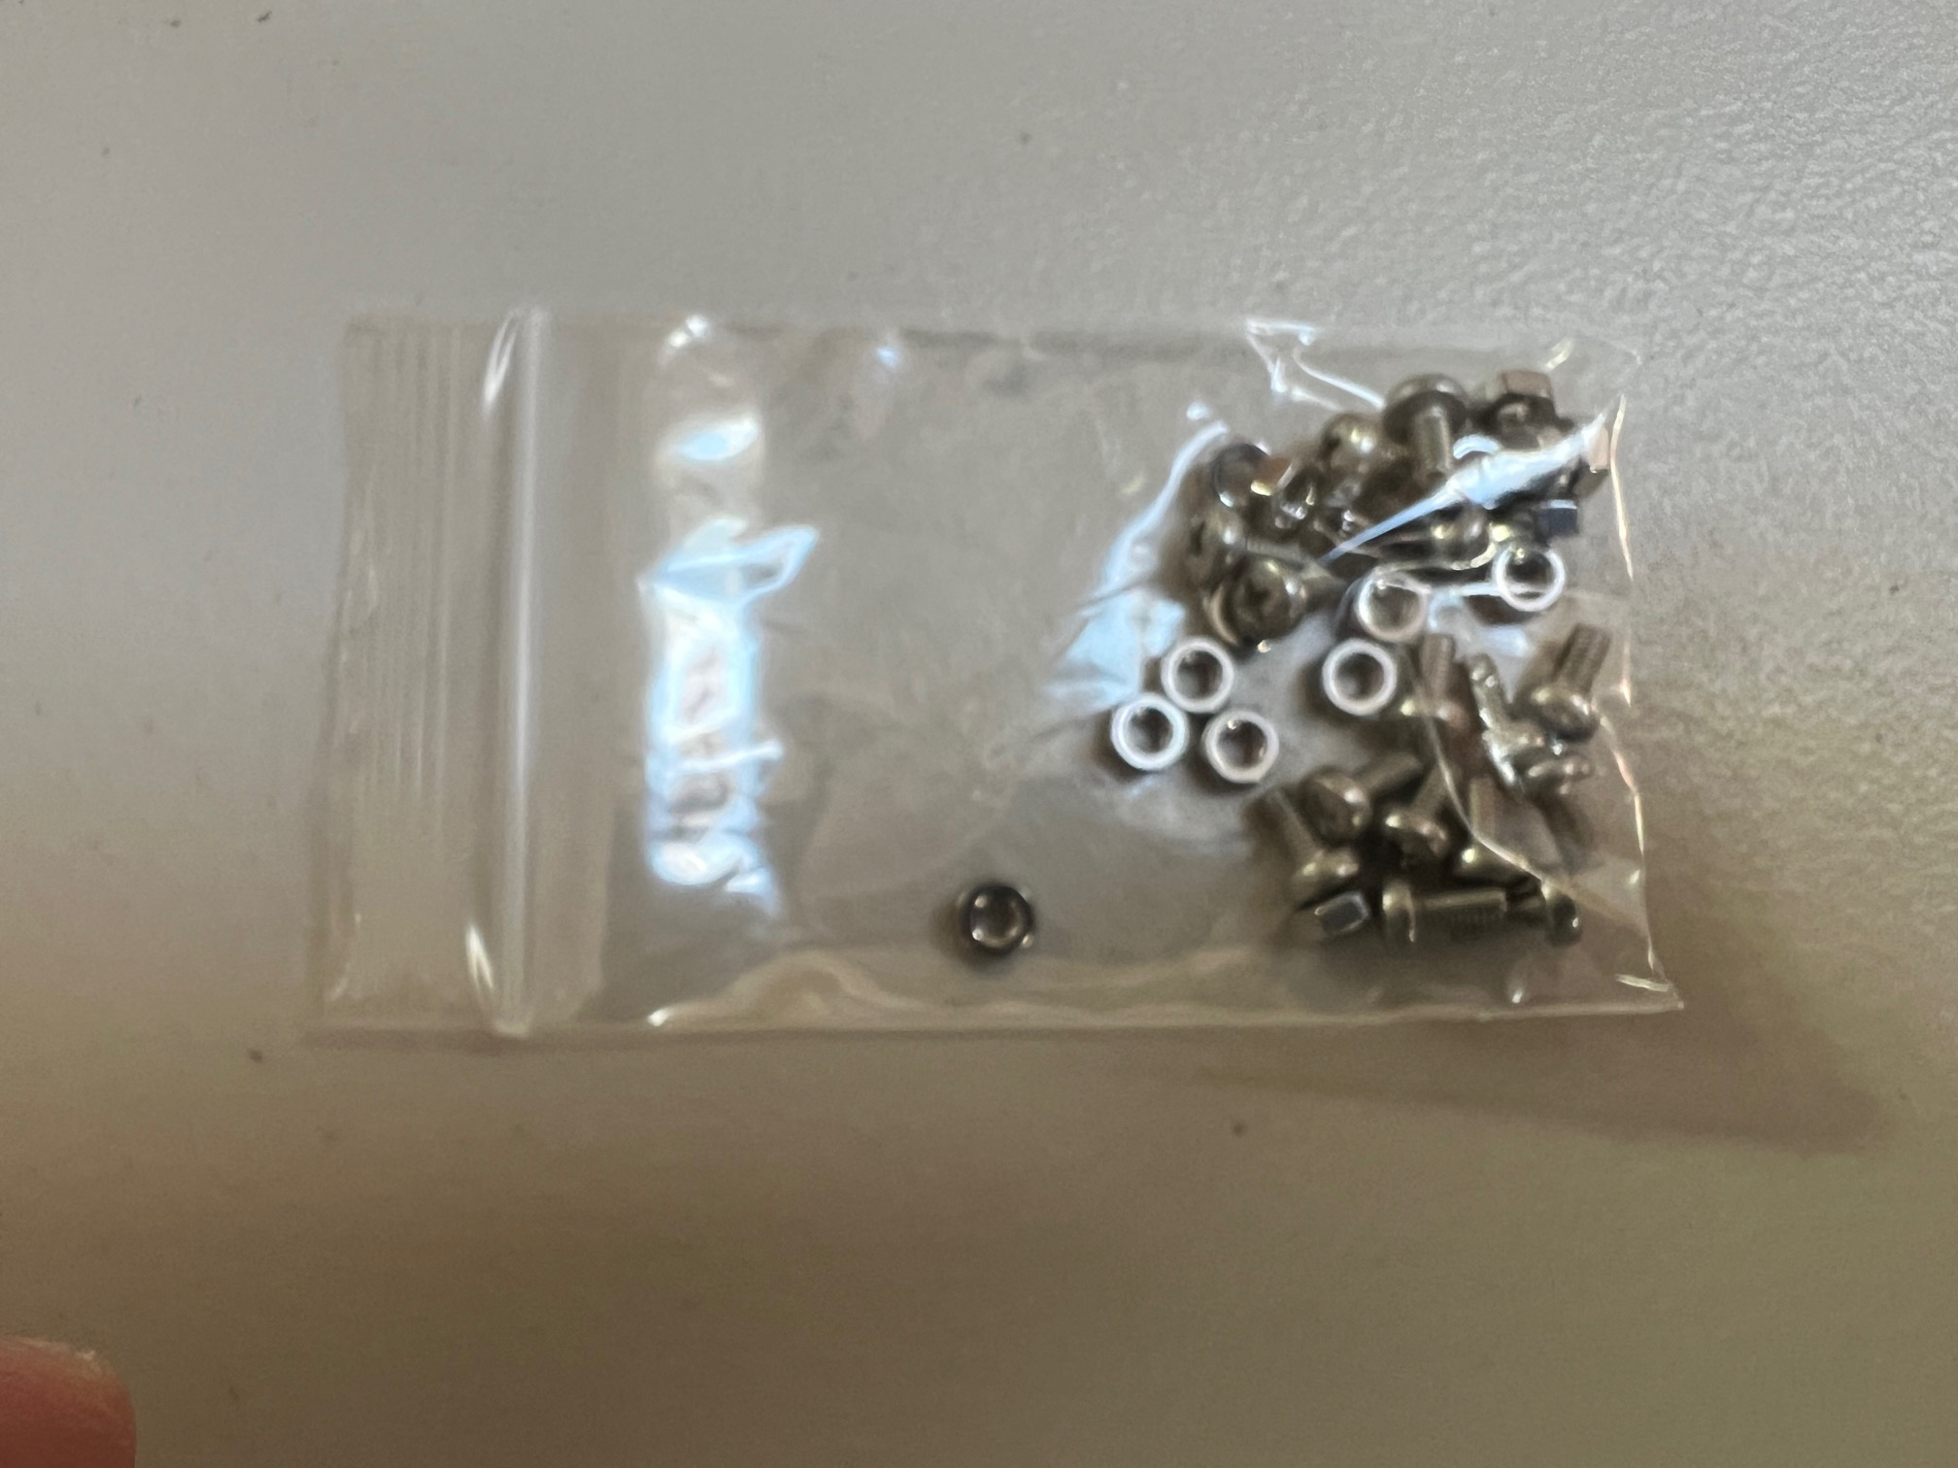
Type N connectors | 2 | 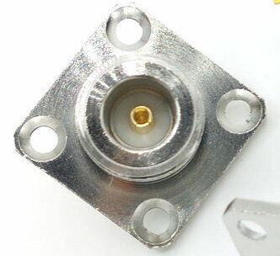
Type SO-239 connectors | 2 | 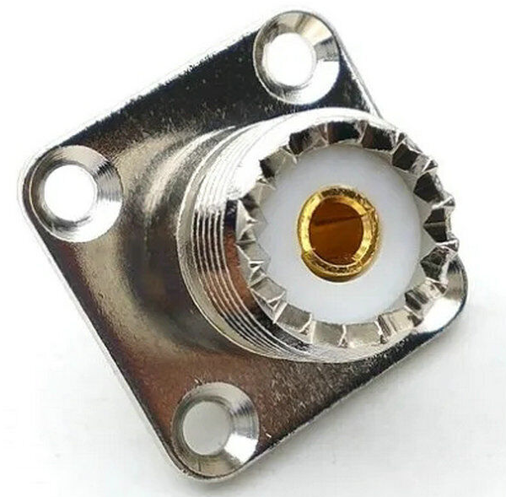
Type BNC connectors | 2 | 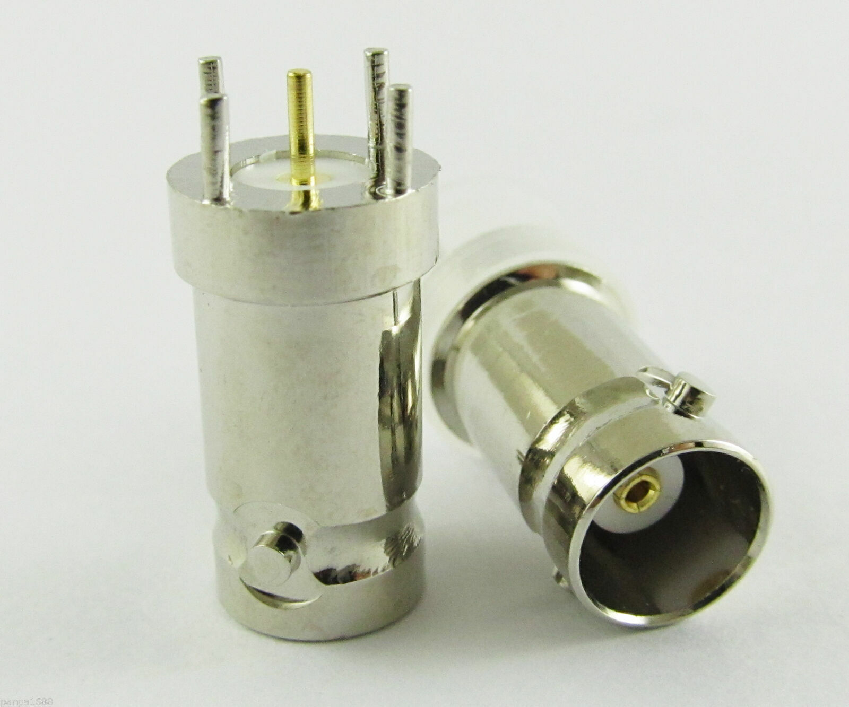
Type Banana connectors: 1 Red, 1 Black | 2 | 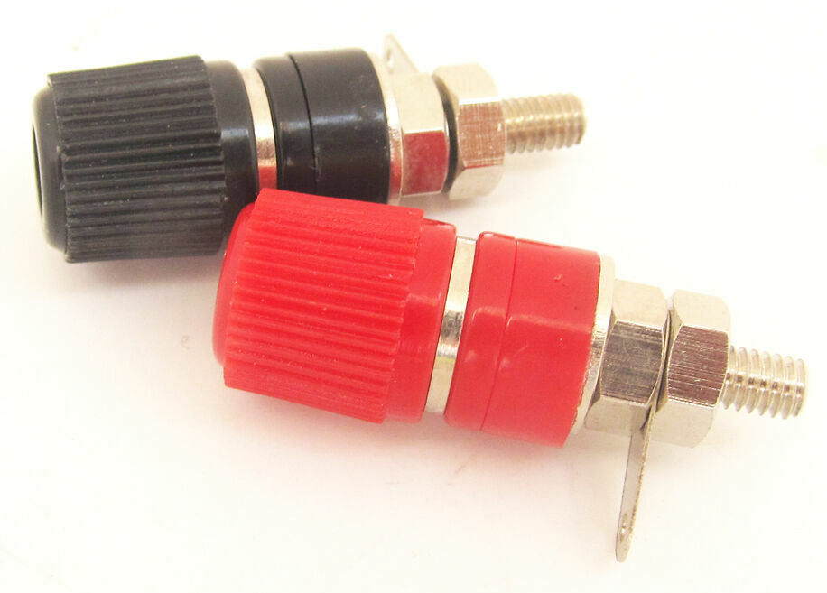
Type SMA connectors | 4 | 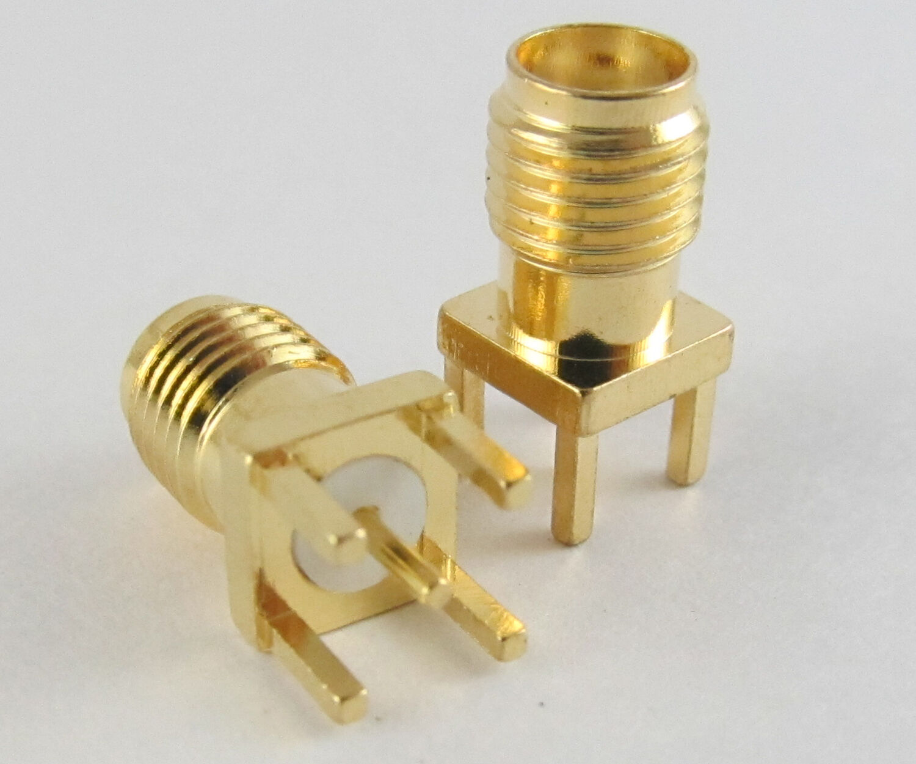
SPDT Switches | 3 | 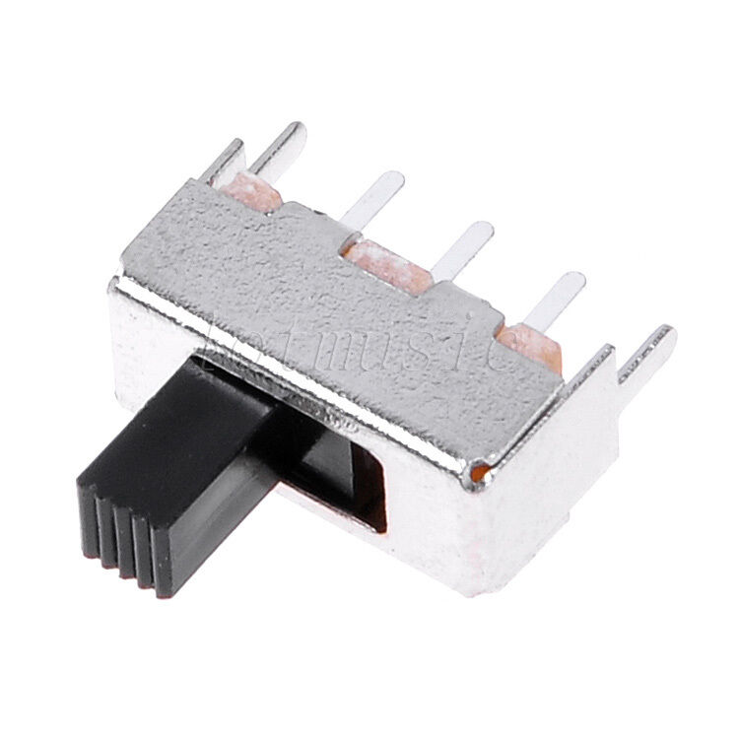
SP3T Switches | 2 | 

